EXPERIMENT: PLANETS DATABASE USING PROLOG
QUESTION
Write a Prolog program to create a database of planets in the Solar System and retrieve planet information using queries.
AIM
To write and execute a Prolog program to create a database containing the names of the eight planets and their order from the Sun.
PROCEDURE
- Open the SWISH Prolog editor.
- Define facts containing the names of the eight planets and their order from the Sun.
- Create a rule to retrieve planet information.
- Enter the program in the editor.
- Execute the program using suitable queries.
- Display the results.
- Stop the program.
PROGRAM
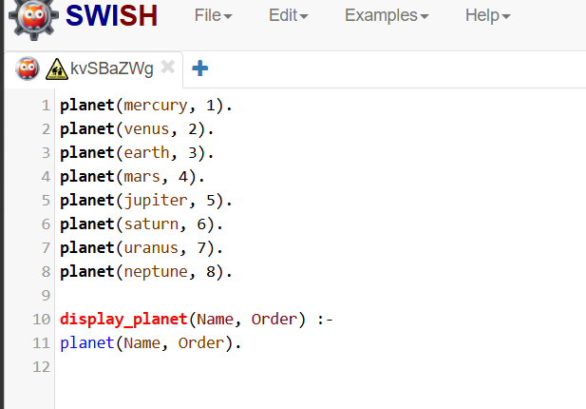
OUTPUT
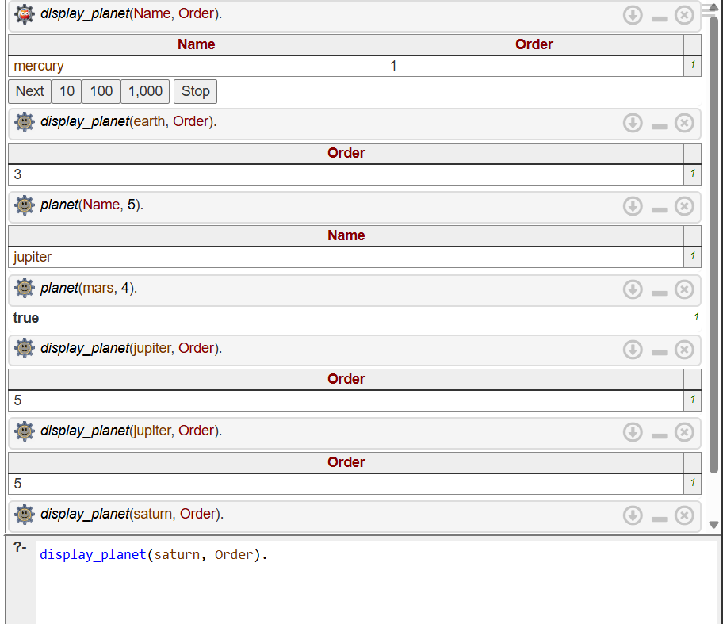

RESULT
Thus, the Prolog program to create a planets database and retrieve planet information using queries was successfully executed.

